Regulatory Committee
Meeting to be held on 18 September 2019

Part I

Electoral Division affected:
South Ribble West

Wildlife and Countryside Act 1981
Definitive Map Modification Order Investigation
Upgrading to Bridleway of Footpath Longton 42 (Known as Six Acre Lane), South Ribble
File No. 804-607
(Annex ‘A’ refers)

Contact for further information:
Joanne Lawson, 01772 533878, Paralegal Officer, County Secretary and Solicitors Group, joanne.lawson@lancashire.gov.uk
Jayne Elliott, 01772 537663, Public Rights of Way Definitive Map Officer, Environment and Planning Group, jayne.elliott@lancashire.gov.uk

Executive Summary

Application for the upgrading to Bridleway of Footpath Longton 42 (known as Six Acre Lane), in accordance with File No. 804-607.

Recommendation

That the application for the upgrading of Footpath Longton 42 to Bridleway, in

accordance with File No. 804-607, be accepted subject to a status of restricted byway, which includes bridleway rights.

That an Order be made pursuant to Section 53 (2)(b) and Section 53 (3)(c)(i)

of the Wildlife and Countryside Act 1981 to upgrade Footpath Longton 42 to a Restricted Byway on the Definitive Map and Statement of Public Rights of Way as shown on the Committee Plan between points A-B-C.

That being satisfied that the test for confirmation can be met the Order be

promoted to confirmation.

Background

An application under Schedule 14 of the Wildlife and Countryside Act 1981 has been received for Footpath Longton 42 (known as Six Acre Lane) to be upgraded on the Definitive Map and Statement of Public Rights of Way from footpath to bridleway from Drumacre Lane East to Gill Lane, Longton, as shown between point A and point C on the Committee plan.

The county council is required by law to investigate the evidence and make a decision based on that evidence as to whether a public right of way exists, and if so its status. Section 53(3)(b) and (c) of the Wildlife and Countryside Act 1981 set out the tests that need to be met when reaching a decision; also current Case Law needs to be applied.

An order for upgrading a way shown on the Definitive Map and Statement will only be made if the evidence shows that:
- "it ought to be there shown as a highway of a different description"

And that:

- “the expiration… of any period such that the enjoyment by the public…raises a presumption that the way has been dedicated as a public path or restricted byway”

When considering evidence, if it is shown that a highway existed then highway rights continue to exist (“once a highway, always a highway”) even if a route has since become disused or obstructed unless a legal order stopping up or diverting the rights has been made. Section 53 of the Wildlife and Countryside Act 1981 (as explained in Planning Inspectorate’s Advice Note No. 7) makes it clear that considerations such as suitability, the security of properties and the wishes of adjacent landowners cannot be considered. The Planning Inspectorate’s website also gives guidance about the interpretation of evidence.

The county council’s decision will be based on the interpretation of the evidence discovered by officers and documents and other evidence supplied by the applicant, landowners, consultees and other interested parties produced to the county council before the date of the decision. Each piece of evidence will be tested and the evidence overall weighed on the balance of probabilities. It is possible that the council’s decision may be different from the status given in any original application. The decision may be that the routes have public rights as a footpath, bridleway, restricted byway or byway open to all traffic, or that no such right of way exists. The decision may also be that the routes to be added or deleted vary in length or location from those that were originally considered.

Consultations

South Ribble Borough Council

A consultation letter was sent on 23 July, no response has been received.

Longton Parish Council

A consultation letter was sent on 23 July, no response has been received.

Applicant/Landowners/Supporters/Objectors

The evidence submitted by the applicant/landowners/supporters/objectors and observations on those comments are included in Advice – Head of Service – Legal and Democratic Services Observations.

Advice

Head of Service – Planning and Environment

Points annotated on the attached Committee plan.

Point | Grid Reference (SD) | Description
A | 4945 2464 | Open junction with Drumacre Lane East
B | 4947 2442 | Concrete blocks positioned across the route restricting vehicular access
C | 4950 2418 | Open junction with Gill Lane

Description of Route

A site inspection was carried out in June 2019.

The application route commences at a point on Drumacre Lane East immediately to the west of Pipe House Farm (point A on the Committee plan).

At point A, the route is signposted as a public footpath and a blue and white road sign is also present with the words 'Six Acre Lane'.

The route extends along a tarmac roadway approximately 3 metres wide with grass verges on either side in a southerly direction providing vehicular access to a number of residential properties located on either side of it.

It continues along the tarmac roadway for approximately 85 metres before the tarmac roadway curves east into the driveway of 'Moorfield' immediately north of point B.

The application route continues south in a straight line past the entrance to Moorfield between some large concrete blocks positioned across the route at point B to continue as a grass track between trees. The available width of the route is approximately 2 metres and there is evidence that a grass strip has been cleared to keep the central section of the route open and not overgrown. The route is bounded on either side by ditches and fences within a strip of land approximately 9 metres wide being enclosed as part of the track, largely overgrown with the exception of the central strip.

On approaching the end of the route where it exits onto Gill Lane at point C, the last 60 metres of the route adjacent to the property known as 'Glenavon' has been surfaced with stone chippings to provide access to the side and rear of the property.

Access onto Gill Lane from the route was open and unrestricted and signed as a public footpath.

The total length of the route is 470 metres.

Map and Documentary Evidence

A variety of maps, plans and other documents were examined to discover when the route came into being, and to try to determine what its status may be.

Document Title | Date | Brief Description of Document & Nature of Evidence
Yates’ Map  of Lancashire | 1786 | Small scale commercial map. Such maps were on sale to the public and hence to be of use to their customers the routes shown had to be available for the public to use. However, they were privately produced without a known system of consultation or checking. Limitations of scale also limited the routes that could be shown.
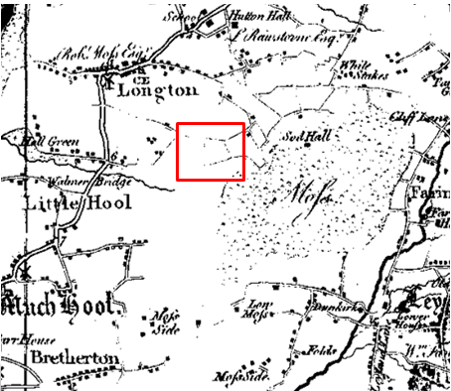
Observations |  | The map faintly shows the road now known as Drumacre Lane East and also Gill Lane east of the application route but does not show either road extending west from the application route. A short 'line' is shown in the proximity of the application route close to the junction with Drumacre Lane East and further east a longer line is shown which appears to connect Drumacre Lane East and Gill Lane and looks to be the route known as 'Land Lane'. A large area south of the application route is blank on the map.
Investigating Officer's Comments |  | The application route may have existed – at least in part – in 1786 – but does not appear to have been considered a substantial public vehicular highway. It could also be that the route was not shown as it was unenclosed or possibly that this area had not been surveyed – as suggested by the blank area of mapping to the south – as surveys were expensive.
Greenwood’s Map of Lancashire | 1818 | Small scale commercial map. In contrast to other map makers of the era Greenwood stated in the legend that this map showed private as well as public roads and the two were not differentiated between within the key panel.
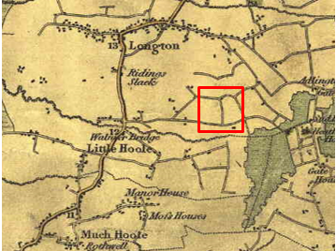
Observations |  | The application route is clearly shown as a through route connecting Drumacre Lane East and Gill Lane. It is shown depicted as a 'cross road' in the same way as Land Lane to the east and to the two public vehicular highways that it connects.
Investigating Officer's Comments |  | The application route existed as a through route in 1818. The inclusion of the route on a small scale commercially produced map of this kind is suggestive of the fact that the route is likely to have been considered to have been a public carriageway or at least a bridleway. It is unlikely that a map of this scale would show footpaths. It is not known what Greenwood meant by the term 'cross road' but he only categorised roads as 'cross roads' and 'turnpike roads' according to the key to his map.
Hennet's Map of Lancashire | 1830 | Small scale commercial map. In 1830 Henry Teesdale of London published George Hennet's Map of Lancashire surveyed in 1828-1829 at a scale of 71/2 inches to 1 mile. Hennet's finer hachuring was no more successful than Greenwood's in portraying Lancashire's hills and valleys but his mapping of the county's communications network was generally considered to be the clearest and most helpful that had yet been achieved.
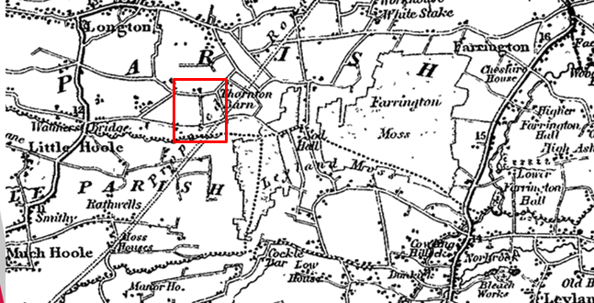
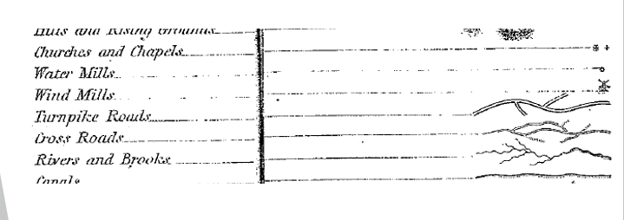
Observations |  | The application route is shown as a through route connecting Drumacre Lane East and Gill Lane and is depicted as a 'cross road' in the same way as other routes now recorded as public vehicular highways.
Investigating Officer's Comments |  | The application route existed as a significant through route in 1830. It is not fully known what is meant by the term 'cross road'. As the only other category of 'road' shown on the map are turnpike roads, it is possible that a cross road was regarded as either a public minor cart road or a bridleway (as suggested by the judge in Hollins v Oldham). It is unlikely that a map of this scale would show footpaths.
Canal and Railway Acts |  | Canals and railways were the vital infrastructure for a modernising economy and hence, like motorways and high speed rail links today, legislation enabled these to be built by compulsion where agreement couldn't be reached. It was important to get the details right by making provision for any public rights of way to avoid objections but not to provide expensive crossings unless they really were public rights of way. This information is also often available for proposed canals and railways which were never built.
Observations |  | There are no proposed or existing canals or railways affecting the land crossed by the application route.
Investigating Officer's Comments |  | No inference can be drawn with regards to the existence of public rights.
Tithe Map and Tithe Award or Apportionment  Longton Tithe Map and Award  CRO Ref: DRB1/127 | 1839 | Maps and other documents were produced under the Tithe Commutation Act of 1836 to record land capable of producing a crop and what each landowner should pay in lieu of tithes to the church. The maps are usually detailed large scale maps of a parish and while they were not produced specifically to show roads or public rights of way, the maps do show roads quite accurately and can provide useful supporting evidence (in conjunction with the written tithe award) and additional information from which the status of ways may be inferred.
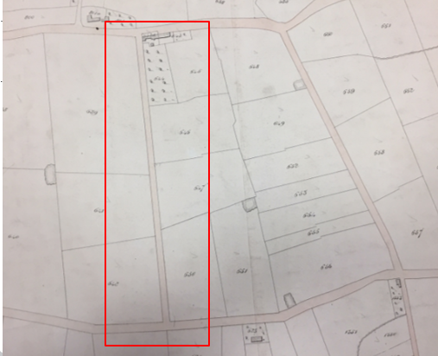
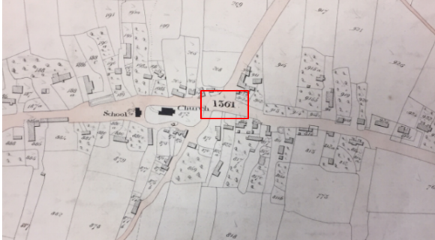
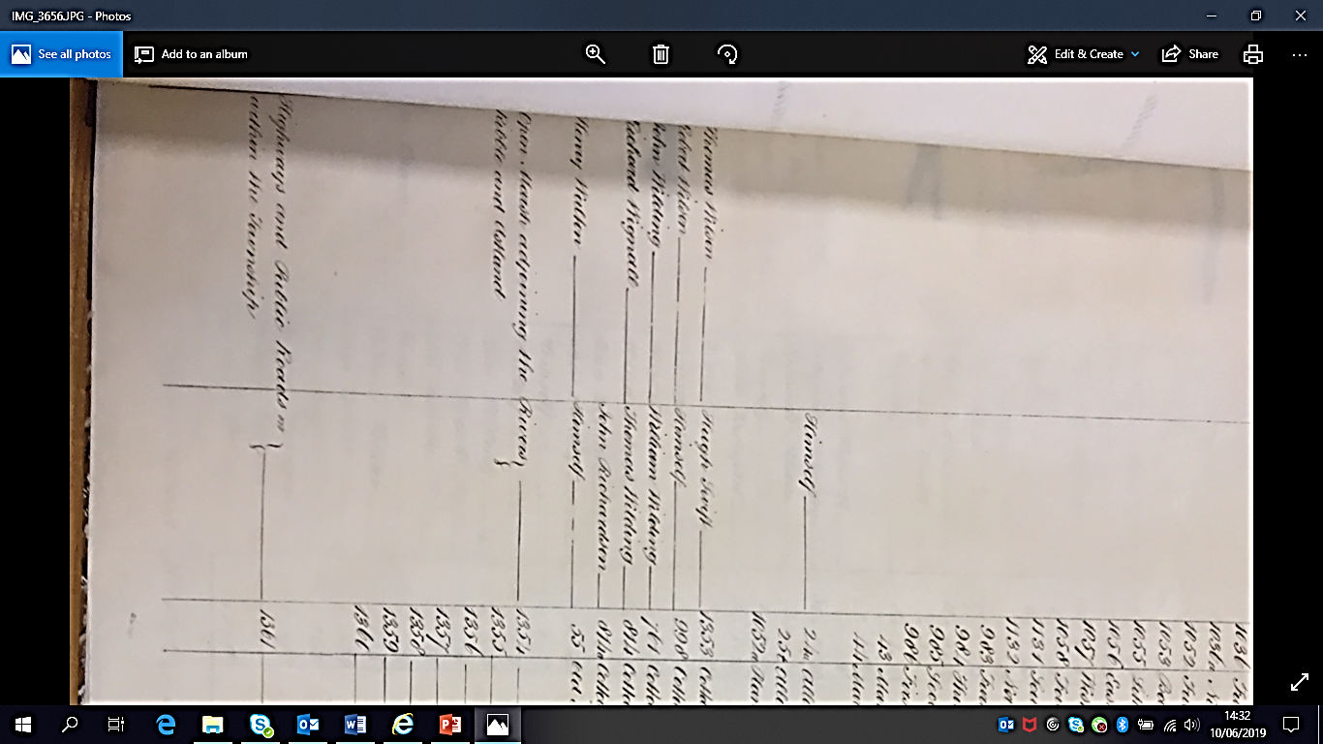
Observations |  | The application route is clearly shown on the Tithe Map as an unrestricted through route coloured in the same way as the public vehicular routes in the parish. The route is not individually numbered but one number – which has been written in bold, and larger than the numbering used for individual plots and located in the 'centre' of the village – appears to relate to the coloured road network shown. This number – 1361 – is described in the Tithe Award as being the reference given for 'Highways and public roads within the township' for which no landownership details were listed and no tithes were listed as being payable.
Investigating Officer's Comments |  | The application route existed as a substantial route in 1839 and was considered to form part of the public highway network at that time. It is not known what distinction (if any) was meant within the Tithe award between 'Highways' and 'public roads' but it appears that the route was considered to be more than a public footpath and probably as part of the public vehicular network used on horseback and with horse and cart at that time.
Inclosure Act Award and Maps |  | Inclosure Awards are legal documents made under private acts of Parliament or general acts (post 1801) for reforming medieval farming practices, and also enabled new rights of way layouts in a parish to be made. They can provide conclusive evidence of status.
Observations |  | There is no Inclosure Award available to view for the area crossed by the application route.
Investigating Officer's Comments |  | No inference can be drawn with regards to the existence of public rights.
1 inch Ordnance Survey (OS) Map Sheet 89NW | 1842 | The earliest OS 1 inch map for the area published in 1842 (date of survey not known).
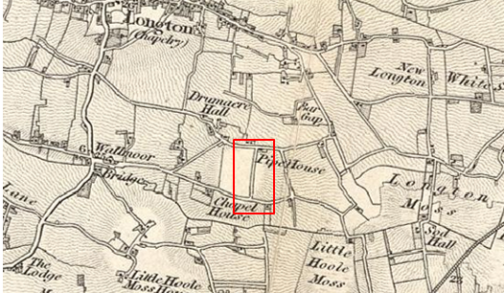
Observations |  | The earliest Ordnance Survey map examined shows clearly shows the application route as a substantial bounded through route in the same way as connecting public vehicular highways are shown.
Investigating Officer's Comments |  | The application route is shown on a small scale Ordnance Survey map in the same style as other non-turnpiked roads. The small scale one inch OS map was predominantly published with the main market being the travelling public so the inclusion of the route on this map is suggestive of a route that was capable of being used at least on horseback and possibly by horse and carts.
6 Inch Ordnance Survey (OS) Map Sheet 68 | 1848 | The earliest Ordnance Survey 6 inch map for this area surveyed in 1844-45 and published in 1848.
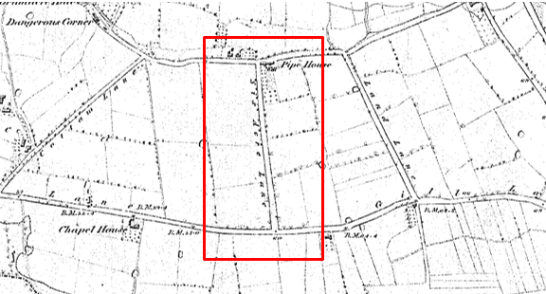
Observations |  | The whole length of the application route is shown as a through route.  The route is named on the map – Six Acre Lane – and so are the other public vehicular highways connecting to it. No barriers are shown across the route suggesting that it was ungated and access restricted.
Investigating Officer's Comments |  | The full length of the application route existed and appeared to be capable of being used in 1848.  Of note is the fact that Six Acre Lane is clearly named on the map and other named routes on this sheet are recorded as public carriageway. The fact that the application route was named as a road on the map is evidence that it was known locally by that name and is consistent with use of the route by the public at least on horseback at that time.
25 Inch OS Map Sheets 68-08 and 68-12 | 1898 | The earliest OS map at a scale of 25 inch to the mile. Surveyed in 1892 and published in 1898.
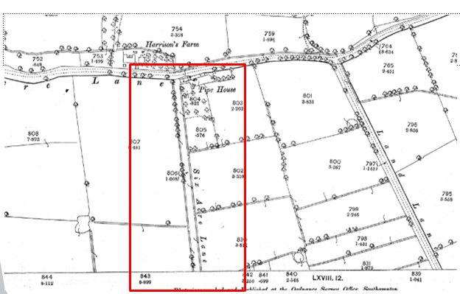
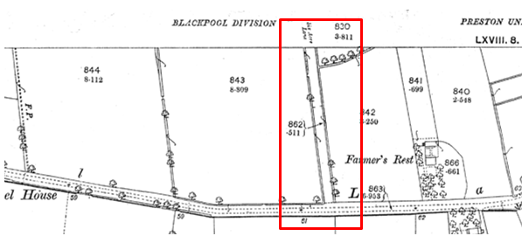
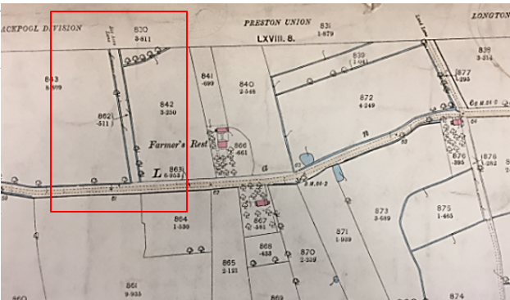
Observations |  | The First Edition 25" OS map is at a larger scale than the 12 and 6" maps showing the area in more detail.  The application route is clearly shown as a substantial bounded route with drainage ditches running along either side. It is named on the map and there are no gates or barriers shown across it.  The route is not coloured or shaded to indicate public status in the way that Drumacre Lane, Land Lane and Gill Lane are shown.  Separate Field Parcel numbers (806 and 862) are allocated to the route and a numbered separately to the adjacent fields. Bracing is shown along the ditches suggesting that the ditches were within the lane itself.
Investigating Officer's Comments |  | The application route existed in 1892 and appeared capable of being used.  Six Acre Lane is clearly named on the map consistent with it being more than footpath.  Shading was often used to show the administrative status of roads on 25 inch maps prepared between 1884 and 1912. All metalled public roads for wheeled traffic kept in good repair by the highway authority were to be shaded and shown with thickened lines on the south and east sides of the road. The application route is not shown in such a way suggesting that by the 1890s use of the route may have begun to decline with Land Lane to the east and Cottam Lane to the west becoming the more significant connections between Drumacre Lane and Gill Lane.  The Planning Inspectorate Consistency Guide states that "Public roads depicted on 1:2500 maps will invariably have a dedicated parcel number and acreage." However, it goes on to say this is far from conclusive evidence of highway status.  The fact that the application route was named as a road on the map is evidence that it was known locally by that name and is consistent with use of the route by the public at least on horseback at that time.
One inch OS Map | 1896 | Sheet 75 published 1896 date of revision not known
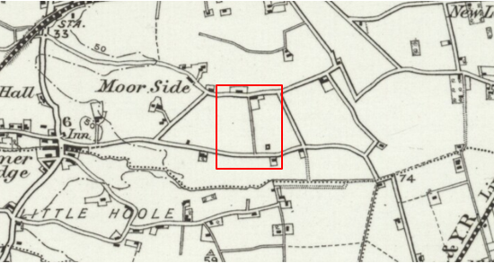
Observations |  | The application route is shown but appears narrower than Drumacre Lane and Gill Lane, Land Lane and Cottam Lane. Whilst still shown, it looks less significant than it did on the earlier edition of the 1 inch map.
Investigating Officer's Comments |  | The application route existed as a through route in 1896 but use as part of the public vehicular network may have declined.
25 inch OS Map | 1911 | Further edition of the 25 inch map surveyed in 1892, revised in 1909 and published in 1911.
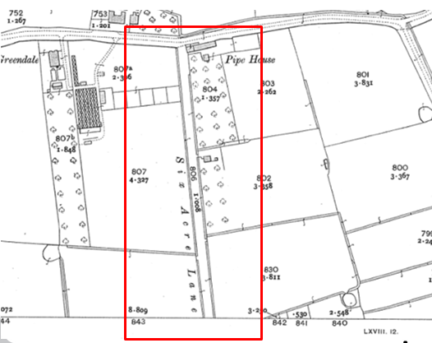
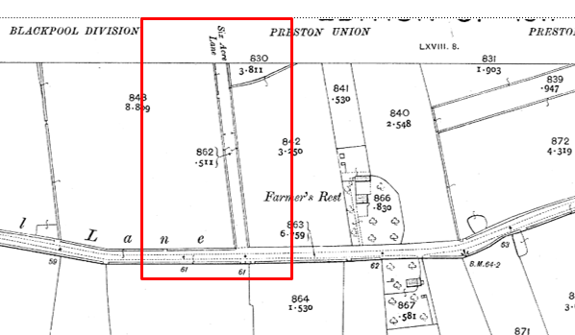
Observations |  | The application route is shown as a bounded and named through route in the same way as it is shown on the earlier edition of the 25 inch map.
Investigating Officer's Comments |  | The application route existed in 1909 and appeared capable of being used on horseback and with vehicles.
Bartholomew half inch Mapping | 1902-1906 | The publication of Bartholomew's half inch maps for England and Wales began in 1897 and continued with periodic revisions until 1975. The maps were very popular with the public and sold in their millions, due largely to their accurate road classification and the use of layer colouring to depict contours. The maps were produced primarily for the purpose of driving and cycling and the firm was in competition with the Ordnance Survey, from whose maps Bartholomew's were reduced. An unpublished Ordnance Survey report dated 1914 acknowledged that the road classification on the OS small scale map was inferior to Bartholomew at that time for the use of motorists.
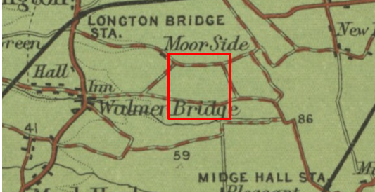
Published 1902

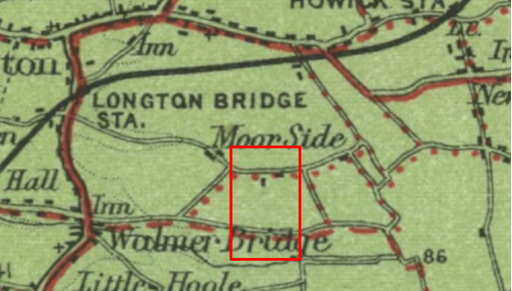
Published 1920

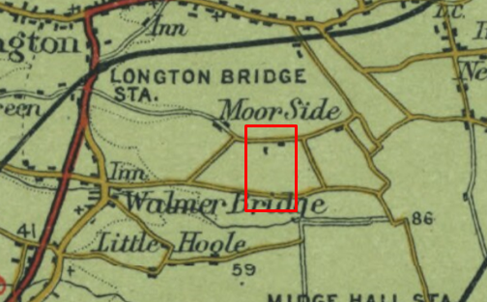
Published 1941

Observations |  | The application route is not shown on any of the three editions of Bartholomew's maps published in 1902, 1920 and 1941.
Investigating Officer's Comments |  | The early 1900s saw a significant increase in the use of motorised vehicles and Bartholomew's maps were popular with both motorists and cyclists during that era.  The fact that the application route is not shown does not mean that it no longer existed (as other maps produced during this time show it). However, it does appear that by the 1900s the route was probably of an inferior surface to Land Lane and Cotton Lane and use of the route had declined.
Finance Act 1910 Map | 1910 | The comprehensive survey carried out for the Finance Act 1910, later repealed, was for the purposes of land valuation not recording public rights of way but can often provide very good evidence. Making a false claim for a deduction was an offence although a deduction did not have to be claimed so although there was a financial incentive a public right of way did not have to be admitted.  Maps, valuation books and field books produced under the requirements of the 1910 Finance Act have been examined. The Act required all land in private ownership to be recorded so that it could be valued and the owner taxed on any incremental value if the land was subsequently sold. The maps show land divided into parcels on which tax was levied, and accompanying valuation books provide details of the value of each parcel of land, along with the name of the owner and tenant (where applicable).  An owner of land could claim a reduction in tax if his land was crossed by a public right of way and this can be found in the relevant valuation book. However, the exact route of the right of way was not recorded in the book or on the accompanying map. Where only one path was shown by the Ordnance Survey through the landholding, it is likely that the path shown is the one referred to, but we cannot be certain. In the case where many paths are shown, it is not possible to know which path or paths the valuation book entry refers to. It should also be noted that if no reduction was claimed this does not necessarily mean that no right of way existed.
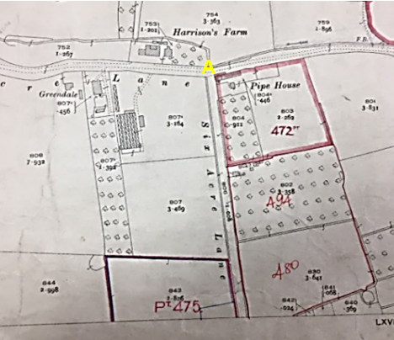
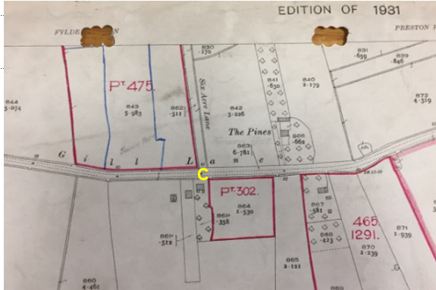
Observations |  | The Finance Act map sheets available to view in the County Records Office are incomplete and show plots drawn onto an Ordnance Survey base map published in 1931 (i.e. 20 years after the date of the Valuation Act) and was presumably a working copy as although the Finance Act was repealed in the 1920s these maps may have continued in use for various purposes. A number of numbered plots are shown on the maps adjacent to but not including the application route but the application route itself is not shown within a numbered plot.
Investigating Officer's Comments |  | As the maps are incomplete and post-dated the original valuation no inference can be drawn with regards to the existence of public rights.
25 Inch OS Map | 1931 | Further edition of 25 inch map (re-surveyed 1892, revised in 1929 and published 1931.
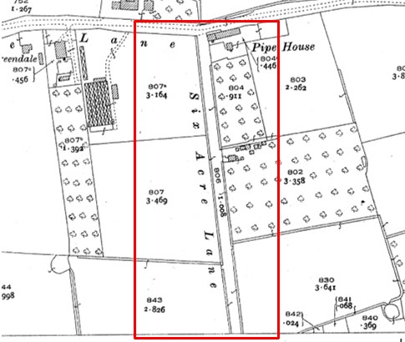
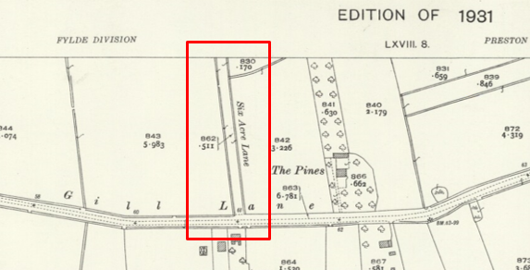
Observations |  | The application route is clearly shown as a bounded through route named on the map as 'Six Acre Lane'. Unlike on earlier editions of the 25 inch OS sheets the name of the lane is no longer printed on the edge of the map sheet to indicate that the route continues onto another map sheet. New buildings are shown south of Pipe House which are accessed from the application route.
Investigating Officer's Comments |  | The application route existed in 1929 and appeared capable of being used.
London Gazette,  25 August 1931 pages 5546-5548 | 1934 | Extract of Legal notice published 25th August 1931 defining the boundary for a separate District for spiritual purposes to be taken partly out of the Parish of Penwortham, partly out of the Chapelry of Longton and partly out of a new parish described as Farington, in the county of Lancaster and Diocese of Blackburn.
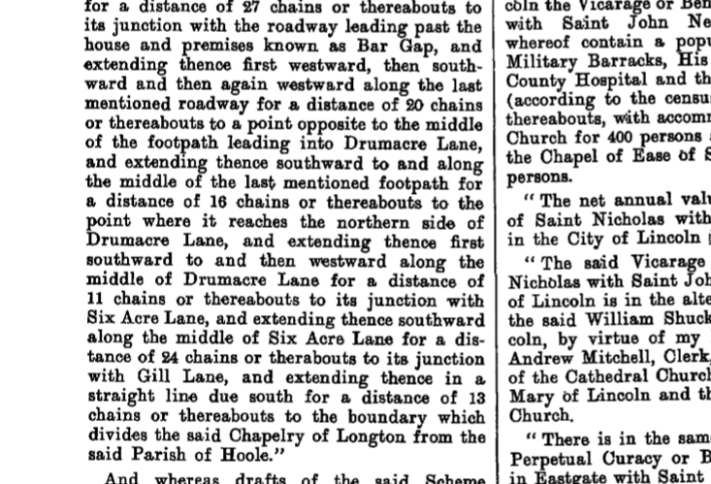
Observations |  | The new boundary of the area created for the purpose of worship is described in writing in the London Gazette as extending from Drumacre Lane along the middle of Six Acre Lane (the application route) to Gill Lane.
Investigating Officer's Comments |  | The fact that the application route is described in a legal notice defining an ecclesiastic boundary as 'Six Acre Lane' – in the same way as other public vehicular highways are named and described illustrates that the route was locally known by that name and suggests use of the route at that time was more than just a 'footpath'.
Authentic Map Directory of South Lancashire by Geographia | Circa 1934 | An independently produced A-Z atlas of Central and South Lancashire published to meet the demand for such a large-scale, detailed street map in the area. The Atlas consisted of a large scale coloured street plan of South Lancashire and included a complete index to streets which includes every 'thoroughfare' named on the map.  The introduction to the atlas states that the publishers gratefully acknowledge the assistance of the various municipal and district surveyors who helped incorporate all new street and trunk roads. The scale selected had enabled them to name 'all but the small, less-important thoroughfares'.
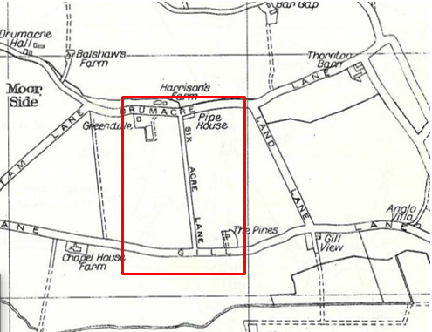
Observations |  | The application route is shown as a bounded through route on the map and is named as Six acre Lane. The route is shown to be narrower than the connecting public highways and whereas the name of Drumacre Lane, Gill Lane, Land Lane and Cottam Lane is written within the boundaries of each of those roads 'Six Acre Lane' is written alongside – not inside the boundaries of the lane itself.
Investigating Officer's Comments |  | The application route existed in the 1930s and was considered to be substantial enough to be included in the street map. However, it is noticeably shown to be narrower than the public vehicular routes it connected to suggesting possibly that use was less significant and possibly more akin to public bridleway use than the other routes at that time.
Aerial Photograph | 1940s | The earliest set of aerial photographs available was taken just after the Second World War in the 1940s and can be viewed on GIS. The clarity is generally very variable.
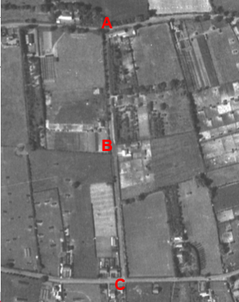
Observations |  | The full length of the application route can be seen. The route appears to provide access to a number of fields and buildings. The route between point B and point C can be clearly seen as a wide bounded route. The 'colour' of the surface of the route differs from how Drumacre Lane and Gill Lane appear on the photograph suggesting that the application route was not a sealed surfaced route.
Investigating Officer's Comments |  | The application route existed in the 1940s as a substantial route and appeared to be capable of being used.
6 Inch OS Map  Sheet 42SE | 1955 | The OS base map for the Definitive Map, First Review, was published in 1955 at a scale of 6 inches to 1 mile (1:10,560). This map was revised before 1930 and is probably based on the same survey as the 1930s 25-inch map.
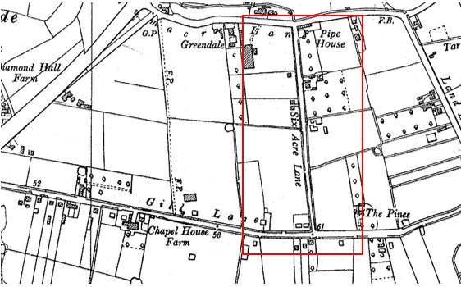
Observations |  | The application route is shown as a significant bounded named through route on the map providing access to a number of properties but also connecting Drumacre Lane and Gill Lane.
Investigating Officer's Comments |  | The application route existed in the 1930s and appeared to be a significant route capable of being used at least on horseback.
1:2500 OS Map  SD 4824-4924 | 1963 | Further edition of 25 inch map reconstituted from former county series and revised in 1961 and published in 1963 as national grid series.
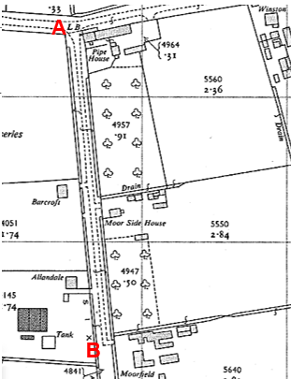
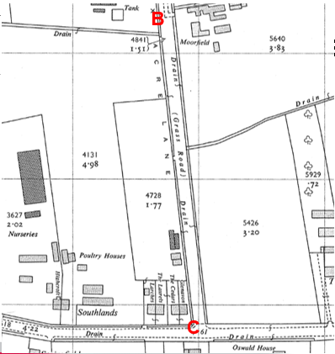
Observations |  | The application route is shown as a through route. From point A dashed line is shown across the start of the route most probably indicating a change in surface from that found on Drumacre Lane (most probably tarmac) to the surface along the application route.  The letters 'LB' are also shown at point A indicating the existence of a letter box (which still exists today).  Between point A to point B there appears to be a surfaced track along the centre of the bounded strip of land comprising the application route from which there is access to Moor Side House, Allendale and Moorfield.  From point B onwards through to point C the application route is described as a 'grass road' bounded by ditches and fencing on either side.
Investigating Officer's Comments |  | The application route existed in 1961 and appeared capable of being used. By this time the northern section (between point A and point B) appears to have formed the access to a number of residential properties and looks to have been surfaced as the main access route. Between point B and point C the route is described as having a grass surface more consistent with public bridleway use.
Aerial photograph | 1960s | The black and white aerial photograph taken in the 1960s and available to view on GIS.
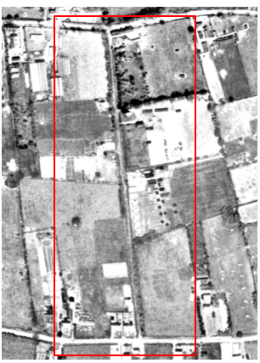
Observations |  | The full length of the application route can be seen as a through route which also provided access to a number of buildings located along side it. A worn track consistent with some vehicular use can be seen along the full length.
Investigating Officer's Comments |  | The application route existed in the 1960s and appeared capable of being used.
Aerial Photograph | 2000 | Aerial photograph available to view on GIS.
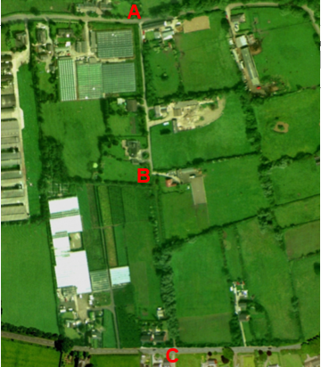
Observations |  | The application route can be clearly seen from point A to point B but beyond point B through to point C it is much less visible.
Investigating Officer's Comments |  | The application route between point A and point B is used by vehicles to access the properties situated along either side of it but use beyond point B through to point C appears to be much less significant and more akin to the use of the route as a public footpath (it's recorded legal status).
Definitive Map Records |  | The National Parks and Access to the Countryside Act 1949 required the County Council to prepare a Definitive Map and Statement of Public Rights of Way.  Records were searched in the Lancashire Records Office to find any correspondence concerning the preparation of the Definitive Map in the early 1950s.
Parish Survey Map | 1950-1952 | The initial survey of public rights of way was carried out by the parish council in those areas formerly comprising a rural district council area and by an urban district or municipal borough council in their respective areas. Following completion of the survey the maps and schedules were submitted to the County Council. In the case of municipal boroughs and urban districts the map and schedule produced, was used, without alteration, as the Draft Map and Statement. In the case of parish council survey maps, the information contained therein was reproduced by the County Council on maps covering the whole of a rural district council area. Survey cards, often containing considerable detail exist for most parishes but not for unparished areas.
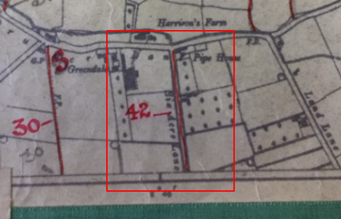
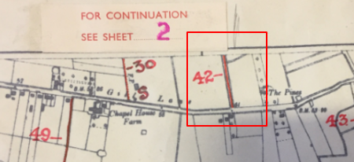
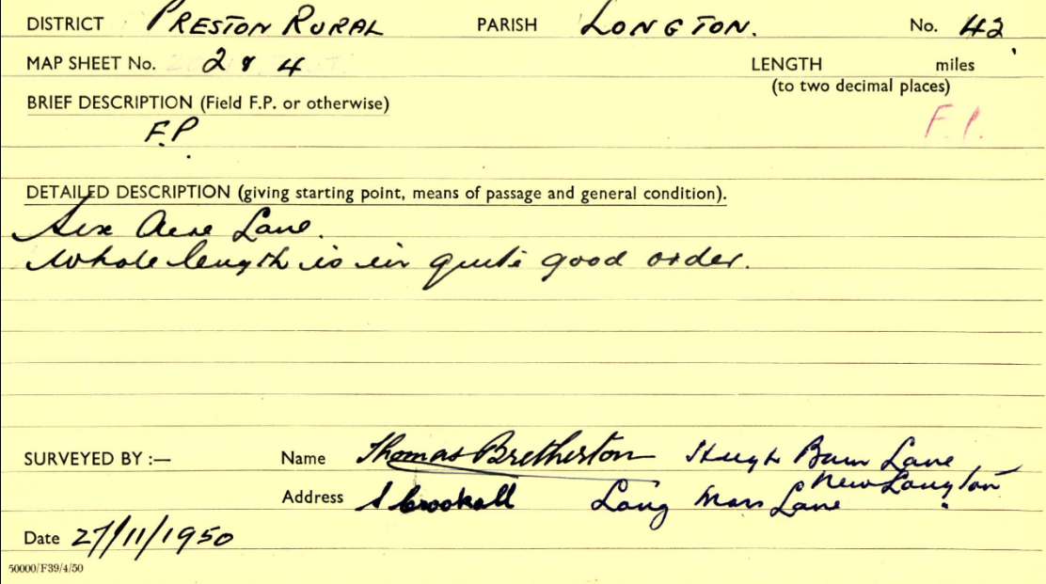
Observations |  | The application route was recorded on the Parish Survey map as a public footpath and was described in 1950 as a footpath known as 'Six Acre Lane' and as being in 'quite good order'.
Draft Map |  | The parish survey map and cards for Longton were handed to Lancashire County Council who then considered the information and prepared the Draft Map and Statement.  The Draft Maps were given a “relevant date” (1st January 1953) and notice was published that the draft map for Lancashire had been prepared. The draft map was placed on deposit for a minimum period of 4 months on 1st January 1955 for the public, including landowners, to inspect them and report any omissions or other mistakes. Hearings were held into these objections, and recommendations made to accept or reject them on the evidence presented.
Observations |  | The application route was shown on the Draft Map as a public footpath and no representations about it were made to the county council.
Provisional Map |  | Once all representations relating to the publication of the draft map were resolved, the amended Draft Map became the Provisional Map which was published in 1960, and was available for 28 days for inspection. At this stage, only landowners, lessees and tenants could apply for amendments to the map, but the public could not. Objections by this stage had to be made to the Crown Court.
Observations |  | The application route was shown on the Provisional Map as a public footpath and no representations were made to the county council.
The First Definitive Map and Statement |  | The Provisional Map, as amended, was published as the Definitive Map in 1962.
Observations |  | The application route was recorded on the First Definitive Map and Statement as a public footpath.
Revised Definitive Map of Public Rights of Way (First Review) |  | Legislation required that the Definitive Map be reviewed, and legal changes such as diversion orders, extinguishment orders and creation orders be incorporated into a Definitive Map First Review. On 25th April 1975 (except in small areas of the County) the Revised Definitive Map of Public Rights of Way (First Review) was published with a relevant date of 1st September 1966. No further reviews of the Definitive Map have been carried out. However, since the coming into operation of the Wildlife and Countryside Act 1981, the Definitive Map has been subject to a continuous review process.
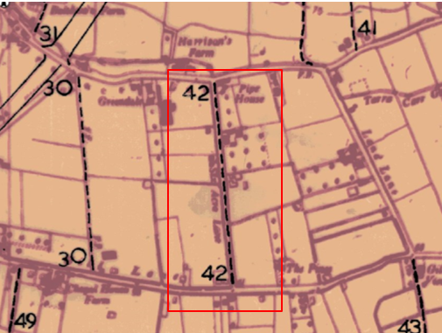
Observations |  | The application route is recorded as a public footpath.
Investigating Officer's Comments |  | From the 1950s through to 1975 there is no indication that the application route was considered to be anything other than a public footpath by the Surveying authority. There were no objections or representations made with regards to the fact that the route was shown as a public footpath when the maps were placed on deposit for inspection at any stage of the preparation of the Definitive Map.
Highway Adoption Records including maps derived from the '1929 Handover Maps' | 1929 to present day | In 1929 the responsibility for district highways passed from district and borough councils to the County Council. For the purposes of the transfer, public highway 'handover' maps were drawn up to identify all of the public highways within the county. These were based on existing Ordnance Survey maps and edited to mark those routes that were public. However, they suffered from several flaws – most particularly, if a right of way was not surfaced it was often not recorded.  A right of way marked on the map is good evidence but many public highways that existed both before and after the handover are not marked. In addition, the handover maps did not have the benefit of any sort of public consultation or scrutiny which may have picked up mistakes or omissions.  The County Council is now required to maintain, under section 31 of the Highways Act 1980, an up to date List of Streets showing which 'streets' are maintained at the public's expense. Whether a road is maintainable at public expense or not does not determine whether it is a highway or not.
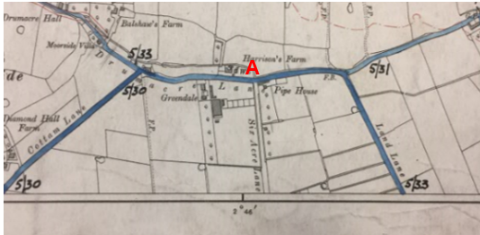
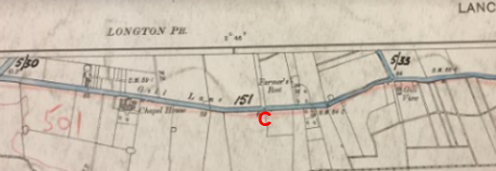
Road Transfer Maps

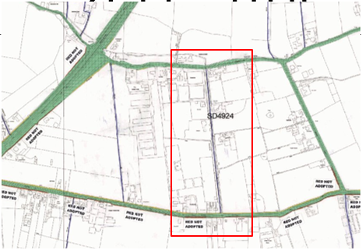
LCC adoption plan

Observations |  | The application route is not shown as a publicly maintainable highway on the Road Transfer Maps prepared circa 1929 although it is currently recorded as a public footpath and is publicly maintainable to at least that status.
Investigating Officer's Comments |  | The application route is recorded as a publicly maintained footpath but this does not necessarily mean that it is not a public highway of a higher status.
Highway Stopping Up Orders | 1835 - 2014 | Details of diversion and stopping up orders made by the Justices of the Peace and later by the Magistrates Court are held at the County Records Office from 1835 through to the 1960s. Further records held at the County Records Office contain highway orders made by Districts and the County Council since that date.
Observations |  | No legal orders diverting or stopping up public rights along the application route have been found.
Investigating Officer's Comments |  | If public rights (additional to recorded Footpath rights) exist along the application route then these rights do not appear to have been stopped up by a legal order.
Statutory deposit and declaration made under section 31(6) Highways Act 1980 |  | The owner of land may at any time deposit with the County Council a map and statement indicating what (if any) ways over the land he admits to having been dedicated as highways. A statutory declaration may then be made by that landowner or by his successors in title within ten years from the date of the deposit (or within ten years from the date on which any previous declaration was last lodged) affording protection to a landowner against a claim being made for a public right of way on the basis of future use (always provided that there is no other evidence of an intention to dedicate a public right of way).  Depositing a map, statement and declaration does not take away any rights which have already been established through past use. However, depositing the documents will immediately fix a point at which any unacknowledged rights are brought into question. The onus will then be on anyone claiming that a right of way exists to demonstrate that it has already been established. Under deemed statutory dedication the 20 year period would thus be counted back from the date of the declaration (or from any earlier act that effectively brought the status of the route into question).
Observations |  | No Highways Act Section 31(6) deposits have been lodged with the county council for the area over which the application route runs.
Investigating Officer's Comments |  | There is no intention by a landowner under this provision of non-intention to dedicate public rights of way over their land.

The affected land is not designated as access land under the Countryside and Rights of Way Act 2000 and is not registered common land.

Landownership

Ownership of most of the land crossed by the application route is not registered.

There are ten separate registered plots of land adjacent to the route three of which appear to include part of the historical width of the route – but which do not include the full width of the route. These are registered titles LAN26363 (Glenavon, Gill Lane), LAN93393 (Allandale, Six Acre Lane) and LA864306 (Moorside House, Six Acre Lane.

The title document for Moorside House includes reference to a notice entered in pursuance of rule 254 of the Land Registration Rules 1925 on 27 April 2000 that the registered proprietor claims that the land has the benefit of a right of way with or without vehicles over and along Six acre Lane leading to Drumacre Lane. The title document for Allandale (purchased by the Vendor in 2009) states that the land has the benefit of a right of way with or without vehicles over and along Six acre Lane and that the right claimed was not included in the registration but was supported by a statutory declaration by Nripendra Kumar Saikia.

The Natural Environment and Rural Communities Act 2006

This Act effected a blanket extinguishment of unrecorded public rights for mechanically propelled vehicles with certain exceptions. Prior to this carriageway rights did not discriminate between vehicles which were mechanically propelled, such as cars and motorbikes, and those which were not, such as bicycles, wheelbarrows, horse-drawn carriages, donkey carts, etc.. If Committee concludes that the evidence shows that, on the balance of probability, public carriageway rights exist on the application route then it is then necessary to consider whether the Natural Environment and Rural Communities Act 2006 has extinguished public rights for mechanically propelled vehicles. Six Acre Lane was, at the time of the Act, recorded as a public footpath and was not on the List of Streets (maintained at public expense) and it does not appear to have been used mainly by the public in mechanically propelled vehicles. There is no claim that any other of the other exemptions apply. Therefore, in the event that public carriageway rights are shown to exist and the appropriate status for Six Acre Lane to be recorded on the Definitive Map and Statement would be Restricted Byway, with public rights with non-mechanically propelled vehicles, horses or on foot.

Summary

There is no user evidence considered as part of this application so it is necessary to look solely at the available map and documentary evidence.

Of significance is that the route is shown on all three small scale early commercial maps pre dating the Ordnance Survey mapping. It is shown as a cross road in the same way as other routes currently recorded as public vehicular highways and appears at that time to have been considered to be part of the public vehicular highway network.

The Tithe Map of 1839 gives further weight to this view with the route shown on the Tithe Map coloured in the same way as the public vehicular highways to which it connects and seemingly described in the Tithe Award as a route considered as a 'highway' and 'public road'.

From the 1840s onwards, the route is consistently shown on all Ordnance Survey maps examined as a bounded through route named on the maps as 'Six Acre Lane'.

Map, aerial photography and site evidence in particular suggest that use of the route as a public vehicular through route probably declined from the end of the 1800s onwards, in favour of use of other parallel public highways (Land Lane and Cottam Lane) and that vehicular use in more recent times has been restricted to use to access private properties alongside the route between point A and point B, with the section between point B and point C being used predominantly on foot and possibly on horseback. However, this would not result in the loss of higher status if that were shown to exist previously.

Head of Service – Legal and Democratic Services Observations

Information from the Applicant

The applicant submitted a number of map extracts as part of the application explaining that Six Acre Lane was always a through road, according to historical map evidence. The applicant stated that no use evidence was submitted as any attempts to ride the route was stopped by residents.

The applicants believe that the route should be a bridleway as it was always a highway and states that street name signs were visible at both ends of the road in 'recent history' but that the 'road' now only has a 'road sign' at the Drumacre Lane East end (Point A).

The following map extracts were submitted without specific comments:

Greenwoods Map of Lancashire 1818
1 inch OS map dated 1885-1900
6 inch OS map dated 1888-1913
25 inch OS map dated 1892-1905
6 inch OS map dated 1848
25 inch OS map dated 1893
6 inch OS map dated 1894
1:1250 OS map dated 1911
6 inch OS map dated 1912
25 inch OS map dated 1931
6 inch OS map dated 1931
6 inch OS map dated 1955
6 inch OS map dated 1961-68
25 inch OS map dated 1963
1:2500 OS plan dated 1969-1991
1:10,000 OS plan dated 1974-1983
25 inch OS map revised 1909, published 1911
25 inch OS map revised 1929 published 1931
25 inch OS map revised 1938, published 1945
1:25,000 OS map published 1955
Ariel view from Bing Maps 2019
Digitised map showing Definitive Public Rights of Way in Lancashire

Information from Others

No further evidence has been submitted
Information from the Landowner

Responses from consultations have been received from a number of landowners who gain access to their properties from Six Acre Lane.

Three of the adjoining landowners have submitted a joint response to the application stating that a public right of way has never existed on this route. The route has always been considered to be a private road maintained by the property owners. No further evidence has been supplied

A further response has been submitted by another land owner whose property is on Six Acre Lane. This landowner states that the route is not suitable to be a bridleway as the route is single tracked with no passing places, and, although there are grass verges on either side there are also deep and wide ditches and the landowner has witnessed a horse fall into such a ditch in a neighbouring location, necessitating removal by the Fire Brigade which was distressing.

Another landowner who owns property on Six Acre Lane has said that they have no objection to the footpath being upgraded to a bridleway.

Assessment of the Evidence

The Law - See Annex 'A'

In Support of Making an Order(s)

The historical mapping evidence shows that the route existed from 1786. The route is shown on the early commercial maps, Yates's Map of Lancashire of 1786, Greenwood's Map of Lancashire of 1818 and Hennet's Map of Lancashire of 1830. It is also shown on the 1839 Tithe Map being described as a highway and a public road. These maps show the route in the same way as other routes that are now recorded as public vehicular highways.

In addition, this route is shown on the first edition and all subsequent editions of the Ordnance Survey maps named as Six Acre Lane on all but the small scale 1 inch maps.

Six Acre Lane is described in the legal notice in the London Gazette of August 1931 in the same way as other public vehicular highways.

There is no evidence that a legal stopping up of any part of the route has ever taken place.

Against Making an Order(s)

Adjacent Landowners consider that the route has no right of way on it and that it is a private road.
It is also considered that the route is unsuitable for use by horses due to its width and the dangers of deep ditches on either side of it.
.

Conclusion

The historical mapping evidence that the route was once used for public vehicular use is strong. The route now carries the status of footpath but in the early 1800s it appears – from its consistent inclusion on small scale early commercial maps and the fact that it was shown in the same way as other public vehicular roads on the Tithe Map in 1839 and described in the Tithe Schedule under the heading 'highway and public road', strongly suggest that it was used by horses and carts and for riding on horseback in the 1800s. On the early maps, the route was shown as the same status as nearby Land Lane and Cottam Lane. Although the use of Six Acre Lane appears to have decreased over time, its initial status as a vehicular highway has not been affected by the more recent use as a footpath only. Once a highway has come into being, it continues indefinitely whether it is used or not. "Mere disuse of a highway cannot deprive the public of their rights. Where there has once been a highway no length of time during which it may not have been used will preclude the public from resuming the exercise of the right to use it if and when they think proper". (Harvey v Truro RDC 1903 2 Ch 638).

There is no evidence to indicate that this historic vehicular highway status has been challenged. Three landowners state that it is a private road which they maintain, but this is recent use by those landowners and does not call into question the historical evidence.

The suitability or otherwise of the route for horses is not something that can be taken into account if highway rights are shown to exist.

If the Committee is minded to accept the application and considers there is adequate evidence to show public vehicular rights it is necessary to consider the Natural Environment and Rural Communities Act 2006. The Natural Environment and Rural Communities Act 2006 would extinguish public rights of way with a mechanically propelled vehicle unless certain exceptions applied but those do not apply here. If Committee accepts the recommendation the correct way of recording the route would be as a restricted bridleway.

Risk management

Consideration has been given to the risk management implications associated with this claim. The Committee is advised that the decision taken must be based solely on the evidence contained within the report, and on the guidance contained both in the report and within Annex 'A' included in the Agenda Papers. Provided any decision is taken strictly in accordance with the above then there is no significant risks associated with the decision making process.

Local Government (Access to Information) Act 1985

List of Background Papers

Paper | Date | Contact/Directorate/Tel
All documents on File Ref: 804-607 |  | Joanne Lawson, 01772 535604, County Secretary and Solicitors Group
Reason for inclusion in Part II, if appropriate

N/A

The Ordnance Survey (OS) has produced topographic maps at different scales (historically one inch to one mile, six inches to one mile and 1:2500 scale which is approximately 25 inches to one mile). Ordnance Survey mapping began in Lancashire in the late 1830s with the 6-inch maps being published in the 1840s. The large scale 25-inch maps which were first published in the 1890s provide good evidence of the position of routes at the time of survey and of the position of buildings and other structures. They generally do not provide evidence of the legal status of routes, and carry a disclaimer that the depiction of a path or track is no evidence of the existence of a public right of way.
Aerial photographs can show the existence of paths and tracks, especially across open areas, and changes to buildings and field boundaries for example. Sometimes it is not possible to enlarge the photos and retain their clarity, and there can also be problems with trees and shadows obscuring relevant features.

